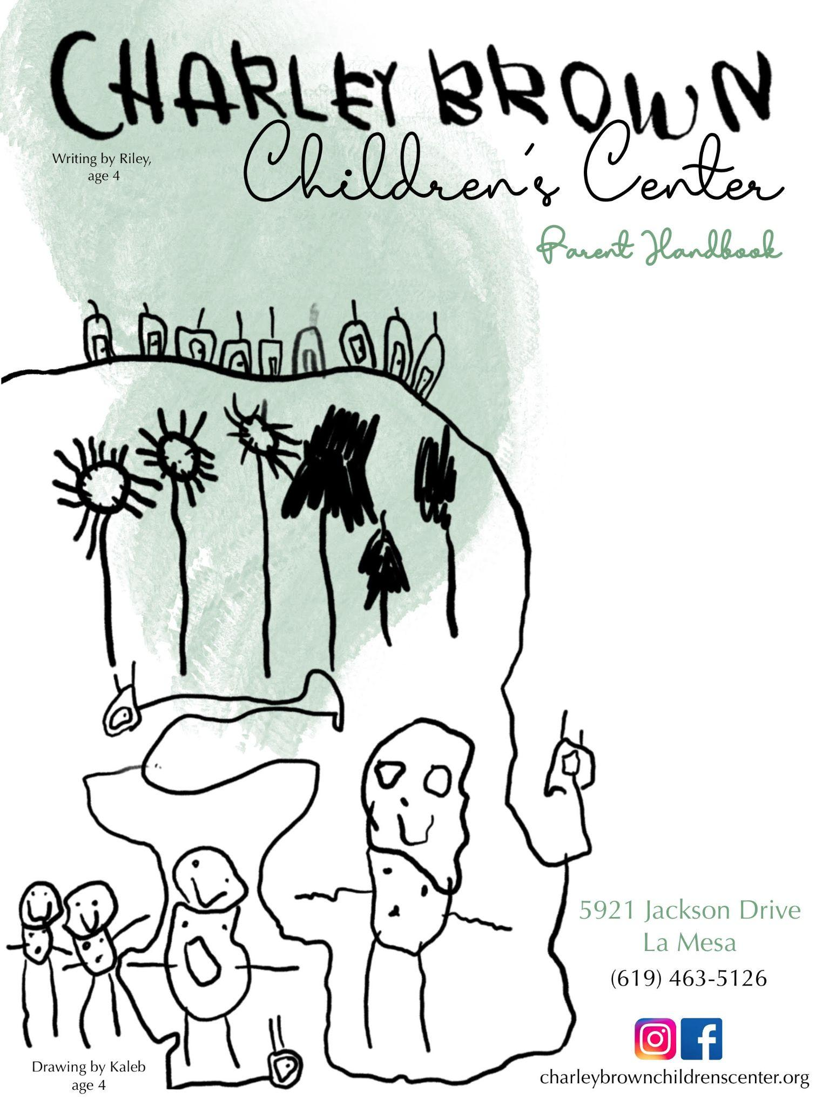
PHILOSOPHY

Charley Brown Children’s Center is dedicated to giving your child the best start in life by laying the foundation for a lifetime love of learning. We are here to provide a quality program that is thoughtful, nurturing and inspiring in an environment that is safe, reliable and explorative.

HOURS AND CARE

The Center is open from 6:00am to 6:00pm, Monday through Friday except for observed holidays and closures. We provide care for infants 6 weeks to 24 months old, toddlers from 18 to 30 months and preschool age children from 30 months to 5 years old. We offer a variety of programs including 5, 4, 3, or 2 full or half days.

ENROLLMENT REQUIREMENTS

The parent/guardian is required to pay a one time, non-refundable fee of $150 per child at the time of registration. The following enrollment requirements must be met before the first day of attendance: registration packet, physical examination performed by a licensed physician, current up to date immunization records and a signed admission agreement.

PROGRAMS

Infant Program: 6 mos - 24 mos

Our Infant Program is separated into “Infant” and “Mobile Infant” classrooms.

Our Infant Program is flexible to the changing routines of every infant. We have created a nurturing and supportive environment that encourages building strong bonds between the caregiver and infant. Each infant’s needs are met throughout the day and recorded for the guardian to see at pick up time each day. The ratio is one caregiver to four infants. Between the ages of 11-14 months, crawling or walking infants will begin a slow transition to the Mobile Infant room.

Our Mobile Infant Program provides an environment where the children get to safely explore the world around them. Before entering this class, many of the growing infants have been on their own schedules and we try our best to accommodate them. This classroom has a ratio of one caregiver to four mobile infants.

Toddler Program: 18 mos - 36 mos

Our Toddler Program is separated into the “Toddler” and “Two Year Old” classroom.

Our Toddler Program follows a classroom routine which is posted in the class. Activities are planned daily and include all academic subjects. Language is developed through reading, dramatic play and social interactions. Potty training is first introduced by the parent and then implemented at the Center. At any time a Toddler can visit the Preschool Program for planned activities. A Toddler can remain in the Toddler room until 36 months if needed. The ratio is one to six.

Our Twos are very busy! They are constantly exploring their environment and learning about the world around them. We encourage this curiosity through an emergent curriculum and social interactions. Our teacher’s provide many opportunities for creative expression including: music and movement, songs, art, dramatic play and games to help each child build skills and self confidence. We work with parents to master potty training before transitioning to the Preschool Program. The ratio is one to twelve.

Preschool Program: 3 yrs to 5 yrs

Our Preschool Program is separated into “Preschool” and “Pre-K” classrooms.

Our Center has four different preschool classrooms. The emergent curriculum is designed to enhance fine motor skills, language development, math concepts, explorations and creativity through components of art, science, math, social studies, and music and movement. This program provides a stimulating environment both in the classroom and outside where children are encouraged to explore, challenged to learn and supported in fostering and creating lasting friendships amongst peers. The ratio remains one to twelve.

With Kindergarten on the horizon, the Pre-K program is an excellent foundation for each child to start their journey of a lifelong love of learning. The emergent curriculum is always changing to meet the needs of the children’s interests. Children will participate in a countless number of hands-on experiences including: art, science experiments, writing, word recognition, cooking, engineering, problem solving and comprehension. Field trips are offered throughout the year to increase community involvement, recreational opportunities and to have fun! Children must have a signed permission slip to attend each field trip along with any necessary fees. We take a school bus to our destination. Walking field trips are also planned. The ratio remains one to twelve.
OUR STAFF

Each of our staff members has education and experience in Early Childhood Education. We stay current on educational practices and attend trainings enabling us to implement the most up to date developmentally appropriate practices while meeting State Licensing regulations. Every employee is required to pass a background clearance through the D.O.J. for Community Care Licensing and the opening and closing staff is CPR/First Aid/AED certified.

CURRICULUM INFLUENCES

We believe children thrive in a supportive home-like environment where they are encouraged by caring adults who observe and learn beside them. Children should be given time, appropriate materials and engage in meaningful interactions to develop intellectually, emotionally and socially. We are inspired by the Reggio Emilia philosophies; Our emergent curriculum style is based on the interests of the students. When they are truly engaged in what they are learning, the opportunities for interest in education are endless.

BEHAVIORAL EXPECTATIONS

Our curriculum is built on observing and listening to one another. Our teachers model care and concern for people and materials, value children’s feelings and ideas, and support children’s strengths and interests. Teachers and students work together to clearly define classroom and community rules, limits, expectations, and appropriate accountability. Teachers use redirection, direct and indirect praise, role modeling and logical consequences to help students practice appropriate school behaviors and self control.

If necessary, a behavior plan may be implemented. These plans are individualized, consistent, and appropriate to each child’s level of understanding and are directed towards teaching the child acceptable behavior and self control.

Behavioral Plans follow these steps*:

1. The teacher defines and documents ongoing misbehavior and notifies management about these concerns. Appropriate solutions are discussed. Children who are creating an unsafe environment for others will be immediately removed from the classroom and parents called.
2. If misbehavior persists, parents will be asked to attend a conference with the teachers and/or the management to determine a behavior management plan and a timeline for implementation. Documentation is continued.
3. After these steps, if there is continued misbehavior, the school may recommend physician or counselor intervention agreeable to the parents. A timeline is established for receiving services and receiving recommendations. Parents and staff review the recommendations together. The instructional staff will implement the strategies recommended by the professional.
4. If the misbehavior persists, if it creates an unsafe environment, or parents do not follow through with professional recommendations, the school will determine the feasibility of keeping the child enrolled.

*If Charley Brown Children’s Center cannot guarantee the safety of the child or other children and staff due to the child’s behavior (consistent abusive and/or harmful behavior toward self, other students and staff or aggressive or disruptive behavior) the child may be required to be removed immediately and without advance notice from CBCC. The Center reserves the right to dismiss any child at the Center’s discretion.

MEALS

Our Center participates in the Child and Adult Care Food Program(CACFP) offered by the United States of Agriculture. The Director is the Civil Rights Coordinator that can assist with any questions or concerns and any information needed regarding the program. For additional assistance, please see the Non-Discrimination Policy. The reimbursement received from the CACFP helps with food costs enabling the Center to offer affordable rates. All meals are served following guidelines from this program. The infant program offers Kirkland Infant formula and infant cereal. You may provide breast milk for your infant. It must be labeled with the child’s first and last name as well as the date. Mothers are welcome to breastfeed in the Infant Room or the staff lounge. When infants are ready for solids, a variety of fruits and vegetables are puréed through a blender on site and applesauce is purchased. By 8 months, beans, cheese, and yogurt are offered. Parents may provide an alternative iron-fortified formula or food with a signed statement with the reason declining the Center’s food. Breakfast, lunch and snack are provided at set times each day for children ages 12 months to 5 years old. Breakfast is available between 8:00-9:00. Lunch is served between 11:15- 12:30. Snack is served from 3:00-3:30. We purchase whole milk, 1% milk and soy milk. A special milk from home will be accepted. Menus are posted each month showing any changes that have been made for the day. Please let us know by your child’s first day of attendance if they are allergic to anything. We are a pork free and nut free facility.

BRIGHTWHEEL

Brightwheel is our online forum for communication between staff and parents regarding updates, incidences, photos, messaging and billing. We also use Brightwheel to maintain attendance.
ACCIDENTS

In the event of an accident, an incident report will be written on Brightwheel stating the specific accident and the procedures that were followed. Should emergency action be needed, a parent will be notified immediately. If a parent is unable to be reached, we will follow their emergency plan. If 911 needs to be called, a staff member will ride with your child to the hospital until a parent or guardian is able to take over.

DISASTER PREPAREDNESS

In the event of a disaster (i.e. Fire, pandemic, power outage, flooding, etc.) CBCC has a Disaster Preparedness Plan to ensure the safety and well-being of our students. Updates will be communicated through Brightwheel. Please understand that parents will be responsible for tuition in the event of an unexpected closure or delay. No refunds will be given.
In the event that we need to evacuate the premises, children will be taken to The United Church of Christ of La Mesa located at 5940 Kelton Avenue or Murray Manor Elementary School located at 8305 El Paso Street.

GOOD HEALTH

Observation and supervision of the health and safety of the children during school hours is the responsibility of the Director and caregivers. If a child becomes ill during the day, he/she will be isolated from the other children and made comfortable until a parent or guardian can be notified and able to take the child home. Any child suffering from the following will not be admitted to the Center: fever of 100.3 or higher, 3 loose bowel movements, vomiting, fatigue or loss of appetite, draining from the eyes, nose or ears, open sores or unexplained rash, nits or lice. Any child that is sent home due to illness cannot return to the Center until 24 hours from the child’s last symptoms.

INCIDENTAL MEDICAL SERVICES

Prescription medication can be administered throughout the day with a completed Medication Authorization Form as long as the medication is in its original packaging. Over the counter homeopathic medication(i.e. Baby Orajel, infant gas drops etc.) can be given in its original packaging with a signed note from a physician. Medicine may not be mixed in drinks or bottles for the safety of all children. Please make sure all medication is turned in to the office.

ITEMS FROM HOME

This packet contains a “What to bring on your first day” information sheet. Children often find comfort in special objects and may bring a small stuffed animal for nap time. The Center is not responsible for any personal items(I.e. toys, books, etc.) that a child brings to school that may get lost, stolen or broken.

HOLIDAYS
CBCC will be closed the following days: two days for New Years, Martin Luther King Jr. Day, Presidents Day, Good Friday, Memorial Day, Juneteenth, Fourth of July, Labor Day, Veteran’s Day, Thanksgiving day and the day after, two days for Christmas and two days for New Years.

VACATIONS

Only full-time students are offered a one week vacation credit twice per year. The office must be notified two weeks in advance or the full-time tuition will be charged. When the office is notified, a $125 credit will be applied to the following month’s invoice. Any adjustments must be for 5 consecutive days in one week. Part time schedules cannot have make-up days. However, if space is available additional days can be added to part-time schedules for an additional fee.

STATE REQUIREMENTS

The Department of Social Services requires all guardians at the time of drop off and pick up to sign in and out with a full legal signature and time of attendance. This is the most important job of the parent/guardian to transfer responsibility to and from the Center and is needed in emergency situations.

The Department of Social Services Community Care Licensing Agency has the authority under Section 101195(b and c) to interview or observe the physical condition of the children, including conditions that could indicate abuse, neglect or inappropriate placement and to inspect all records kept at the Childcare Center without prior parental consent. The licensee shall make provisions for private interviews with any children or staff members and for the examination of all records relating to the operation of the Childcare Center.

Our Center is licensed by CA Community Care Licensing and is subject to the inspection by licensing, fire inspections, state and local health agencies, building agencies as well as CACFP food audits. Regulations and inspections pertain to the facility and playground, the staff qualifications, nutrition, health and safety of children, record keeping for students and staff as well as child to staff ratios.

INCLUSION OF CHILDREN WITH SPECIAL NEEDS

The Center accepts any child whose needs can be met in the childcare setting, provided space is available in the program. In all cases the child must be able to participate to some degree and substantially benefit from the program without risk to him/herself or to the other children and this must be accomplished without fundamentally altering the nature of the program.

Please discuss your child’s needs with the Center Director before enrolling. If you have additional information, documentation or your child has an Individualized Education Program (IEP), please let us know in order to help us provide the best possible care for your child.

NON-DISCRIMINATION POLICY

The U.S. Department of Agriculture prohibits discrimination against its customers, employees, and applicants for employment on the basis of race, color, national origin, age, disability, sex, gender identity, religion, reprisal, and where applicable, political beliefs, marital status, familial or parental status, sexual orientation, or all or part of an idividuals income is derived from any public assistance program, or protected genetic information in employment or in any program or activity conducted or funded by the Department. (Not all prohibited bases will apply to all programs and/or employment activities.)
If you wish to file a Civil Rights program complaint of discrimination, complete the USDA Program Discrimination Compliant Form found online at www.aser.usda.gov/complaint_filing_cust.html, or at any USDA office, or call (866) 632-9992 to request the form. You may also write a letter containing all of the information requested in the form. Send your completed complaint form or letter by mail to: U.S. Department of Agriculture, Director, Office of Adjunction, 1400 Independence Avenue, S.W., Washington D.C. 20250-9410, by fax (202) 690-7442 or email to program.intake@usda.gov. Individuals who are deaf, hard of hearing or have speech disabilities may contact the USDA through the Federal Relay Service at (800)877-8339 or (800)845-6136(Spanish).

PAYMENTS AND ADDITIONAL FEES

All tuition payments are due on the first of the month and payable by the fifth of the month. If a partial payment is necessary, the fees are due on the 15th of the month and payable by the 20th of the month. Bills paid after the due dates will be charged a late fee of $25. You cannot start a new month until your previous balance is paid in full. If necessary, a payment plan may be arranged with the Director.

Additional Fees:
- $15 charge for checks returned for insufficient funds.
- Rotating Day Schedule of $50/month-only when space permits for that month.
- Potty training Fee of $100/month will be removed after 10 consecutive days of no accidents for children 36 months and older.
- $1 per borrowed diaper/$.25 per borrowed wipe
- Over 10 hours/day will incur a weekly charge of $50 if 10 or more hours are noticed on any given day in that week.
- Late pick up: after 6:00pm.(Center’s closing time), charges will be $1.00 per minute after 6:01pm. Charges will increase to $5.00 per minute after 6:15.
- Every year in September (Fiscal year) an annual supply fee of $100 will be billed for each child. The $100 will be used to purchase center supplies (paint, construction paper, new toys, manipulatives, etc.).
- Pre-K: Costs of field trips, graduation and yearbook (between $25-$65 for the year).

PARENT RESPONSIBILITIES

- To sign your child in and out with your full legal signature daily.
- To close all gates and doors each time you enter or leave the facility.
- To notify the Center if your child will be absent or if anyone other than the guardian
will be picking up your child.
- To provide a change of clothes, crib sheet, blanket and diapers/wipes as needed.
- To update your child’s record annually or as changes occur.
- To leave toys and personal items at home.
- To notify the kitchen, teachers and office staff if your child has known allergies.
- To get the appropriate forms filled out by a physician so that we can administer
medication as needed.
- To notify the Center of communicable disease that your child may have been exposed to.
- To ensure that at least one phone number can be contacted on each day incase of an emergency.
- To dress your child in appropriate clothing and shoes to safely play on all playground structures. Heels and flip flops are not acceptable footwear.
- All payments must be made in full before starting a new month of care.
- To fill out all forms that are sent home throughout the year in a timely manner.

What to bring on your first day:

- Enrollment Packet
- Copy of Immunizations
Infants:

- 2 Crib Sheets (We wash and keep them at school)
- 2 Sleep Sacks/Swaddles if sleeping in crib (Per licensing we can not use blankets inside the crib and we only swaddle with arms out)
- 2 Blankets if sleeping on mat on the floor
- Diapers/Wipes (Please write your name on the packs)
- Diaper rash cream
- 3 - 4 Changes of clothes (will be washed at school unless you would like them sent home)
- 3 Pacifiers (if needed)
- 3 Bottles (labeled with the child’s first and last name)
- Breastmilk
  - Each bag must be labeled with first/last name and the date
  - Thawed BM in the fridge must be sent home every night
  - We can store BM in the freezer at school for up to 6 months
+ Formula (If you’d like to provide your own. Must be in the original container, labeled with name and date opened). We provide Kirkland Brand Formula.
+ If your child can sleep on their tummy we require a Doctor’s note giving us the permission to do so. Without the note, any child under 12 months will be put on their backs.
Mobile Infants:

- 1 Crib Sheet & 1 Blanket (We wash them and keep them at school)
- Diapers/Wipes
- Diaper rash cream
- Pacifier (if needed)
- Pair of Shoes/Socks (Closed toed sneakers are recommended for your beginning walker)
- 3 - 4 changes of clothes
- Labeled jacket
Toddlers:

- 1 Crib sheet & blanket (We wash them and keep them at school)
- Diapers/ Wipes
- Diaper rash cream
- Pacifier (to be used during nap only)
- 3 - 4 changes of clothes
- Labeled jackets
Preschool (Twos - PreK):

- 1 crib sheet & 1 blanket (we wash them and keep them at school)
- Backpack, labeled
  - 1 - 2 changes of clothes
  - Reusable water bottle, labeled

If your child is not potty-trained, or in the process of potty training, please bring the following:
- Diapers/Pull-Ups & Wipes
- 3 - 4 changes of clothes
- Diaper Rash Cream
- 1 Pair of Shoes
- 2 - 3 pairs of socks

